Requirements/Design Specification

**On Call Commercial**

**GH 534 – CR 14081**

Revision History

|  |  |  |  |
| --- | --- | --- | --- |
| **Date** | **Revision** | **Description** | **Author** |
| 5/20/2015 | 1.0 | Initial Version with Requirements | Roger Behm |
|  |  |  |  |
|  |  |  |  |
|  |  |  |  |
|  |  |  |  |

The information furnished herein by Republic Services Inc. is proprietary and confidential to Republic Services Inc. personnel and is not to be duplicated, published, or disclosed to any third party in whole or in part without permission from Republic Services, Inc.

© Copyright 2012, Republic Services Inc. - All rights reserved.

Table of contents

1 Business Requirements/Owner – Rich Simon 6

We need to be able to tag a quote as a Broker quote. 6

2 Assumptions 6

3 Design 6

4 InfoPro/TIBCO/BI Impacts 7

5 Report Changes 7

6 Appendix 7

# Business Requirements/Owner – Brittany Smith

# Modify service change to allow service decrease to on-call and service increase from on-call to scheduled (small container).

# Assumptions

We have existing On-Call small containers already in Capture (account_stats table) - John

# Design

Requirements

* Do we allow for service change???
* For new and existing small containers provide an option to perform service change to an On Call container.
  + New price it at once per month
  + Add to the CMC and allow divisions to decide if it will be supported (table update)
  + Lift temp restriction for small containers (how many small temp containers?)
* Use the large container functionality. The frequency dropdown menu should conain and “On Call” option.



* ~~Add estimated lifts to config page and carry to CSA (see figure 3.2)~~



I would drop this…we have to assume <1 haul/month or they wouldn’t be going on call. We don’t need this piece of information

* Default Hauls/Month to 1
* Will have to add haul rate/pick up rate to line item grid to negotiate rate (Brittany to research)
* Do we charge rental along with a pickup rate when requested?
* Compactor would be treated the same – add safety net (charge fot cost)

**Seasonal Pricing Rules**

* **Seasonal Decrease:**  **Scheduled to On Call** - Pricing should be set as follows for on call (same calcs as for scheduled service, just splitting between haul and rental)
  + **REG line should appear in the line item grid, with “Per haul” charge type**
  + On call **cost** = Disposal cost + disposal trip cost + operating expenses +truck depreciation+truck ROA
    - Customer tons= container size*qty containers*div lbs/yd*industry factor/2000
    - Disposal cost = customer tons*cash cost/ton
    - Operating expenses =site time* truck+labor cost/min
      * Site time = min/lift+min/*0.5* (qty containers -1)+site factors
    - Disposal trip cost= truck + labor cost/min+dsp min/ton*tons
    - Truck depreciation = truck depreciation/mo* customer hours/mo/truck hours/mo
      * Customer hours/mo =( site time+disposal min/ton*cust tons)/60
    - Truck ROA =(truck value /2 * customer hours/truck hours)*roi/12
  + On call **floor** = max(on call cost/(1-service change floor margin), customer EXT rate, div EXT rate) [check with Rich if we should use Div EXT if the customer has an EXT)
  + On call **average** = max(on call cost/(1-service change average margin), customer EXT, div EXT)
  + On call **target**= max(on call cost/(1-service change target margin), customer EXT, div EXT)
  + Where the “service change” margin is the margin that results from looking up the customer’s current rate (for scheduled service) in the service change tables and determing what % of new business price they are currently priced at, then applying that margin adjustment from the table their current margin
  + **A rental line should appear in the line item grid – allow to zero out**
  + Rental **cost**= (container maintenance and depreciation+container ROA)
    - Maintenance and Depreciation=( container maintenance cost/lift+container depreciation*container factor*qty containers)*(1-is container customer owned)
    - ROA= (container value*qty containers*(1-is container customer owned)+price/yd average*container size*container qty)*accts receivable/30) *ROA/12
  + Rental **floor** = (rental cost/(1-service change floor guardrail) )* business Rules
  + Rental **average**= (rental cost/(1-service change average guardrail) )* business Rules
  + Rental **target**= (rental cost/(1-service change target guardrail) )* business Rules
* Allocation of price to base rate and fees works as with all other line items
* Rate minimums should not apply to the rental rate or the on call rate
* Price below floor for rental or on call rate should require approval

**Seasonal decrease: scheduled to scheduled**: no change, use existing service change logic – what if service change, need to add seasonal inflaction factor? Potentially pull in rate history

* If schedule or service changes then
  + For ser increase get last service decrease and vice versa – calculate margin apply same margin to new sevice level
* If service does not change make floor = to their last price for the same service

**Seasonal increase: On call to scheduled**

* Need to collect the previous peak rate as a data point. Two options:
  1. Add text box for entry of prior on-peak rate by the rep. This will not be validated
  2. PREFERRED: Look up prior rate in account_rate history (so provide monthly_sales_amt if monthly_yard_cnt from account_rate_history for last service increase – seasonal matches current proposed monthly yards at the new (increased) service level
     + Ex: customer going from on call to 1x/week for 8 yd, so monthly yards going from 0 to 8*4.33 = 34.64. Last service increase showed monthly_sales_amt of $300 and monthly_yard_cnt of 34.64. Set Prior_On_Peak_Rate to $300
     + If Monthly yardage does not match, then prior_on_peak rate is displayed in box on screen and is editable
     + If Monthly yardage does match, then prior_on_peak_rate is displayed on screen and is non-editable
* Need to add an attribute: seasonal inflation factor. Should be table driven. Use corp control table (does not need to be division specific). 1.05, 1.10, 1.15 = seasonal inflation factors for floor, average, and target
* **Cost** for new service will be calculated according to service details
* **Floor** for new service is the max of (prior rate * 1.00)
* **Average** for the new service is obtained by taking the max of prior rate * 1.05
* **Target** for the new service is obtained by taking the max of prior rate * 1.10
* SR popup box would need to change (hide the extra pick from SR box and make sure it is set to $0 in the back ground) – get meeting w/ Info Pro with a list of questions

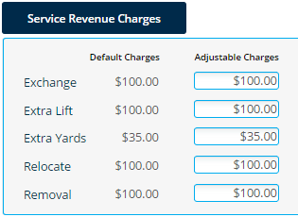

* CSA/Proposal - do the same that we have for large
  + Proposal - haul rate goes in the lift charge column (under base rate), no extra pickup charge
  + Service frequence on CSA would say O/C

Figure 3.1 - Propsal Snippet

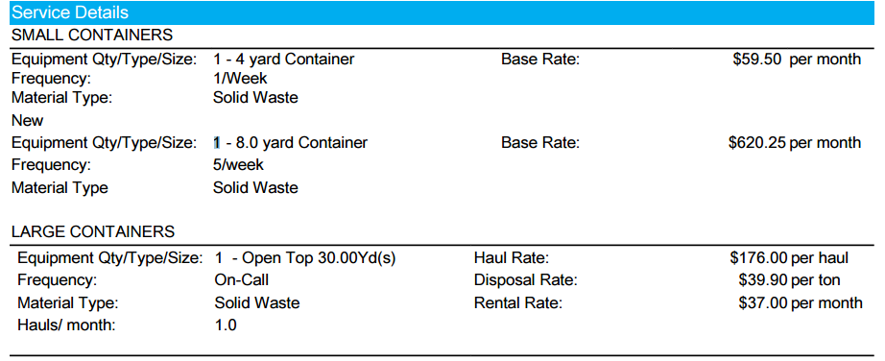

Do we need Hauls/month for O/C small?

$99.99 per haul

Haul Rate:

O/C

Figure 3.2 - CSA Snippet



2

$99.99

O/C

# InfoPro/TIBCO/BI Impacts

New variable may be need as temporary stoage but should not affect TIBCO or any other downstream systems. No existing variables should be repurposed for any of the above changes.

# Report Changes

NA

# Appendix